**Project: SHELVD**

**Project Members: Angel Jackson and Brionna Morris**

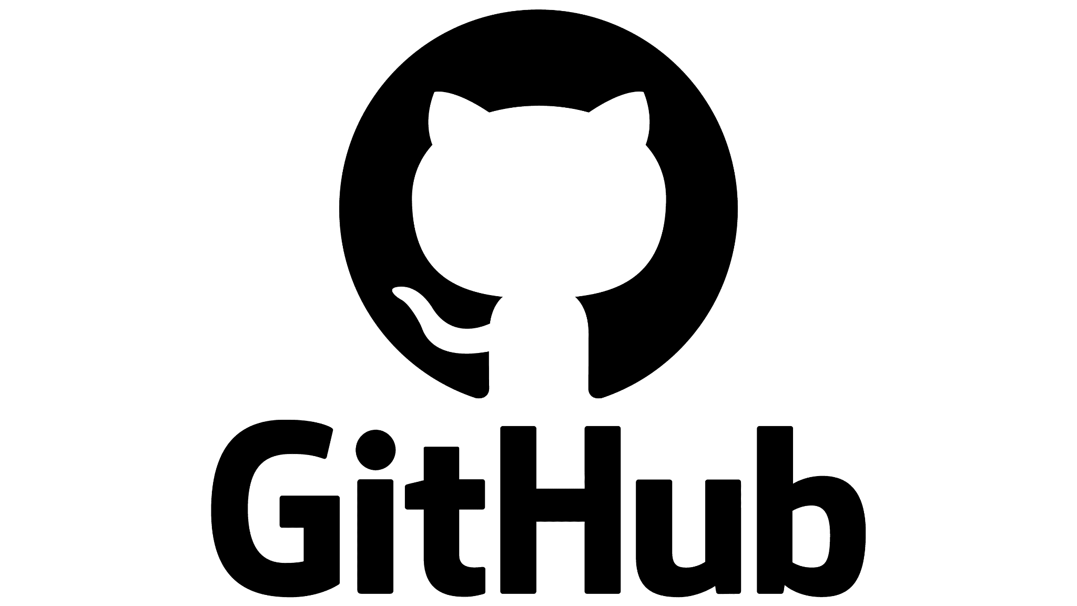 

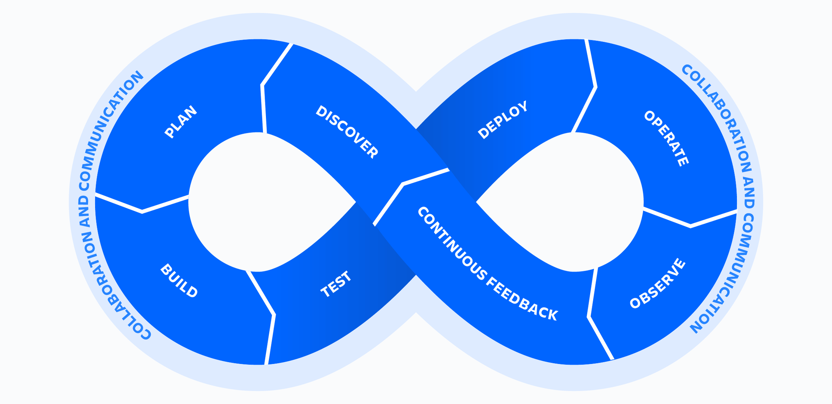



**PLANNING: TRELLO**

Trello is a web-based, kanban-style, list-making application. Trello will be useful in the planning and documenting process of our web application project. Set up similar to a to-do list, we will use Trello to track what has been completed, what needs to be completed, and what will be completed next, to assist with the agile process of the project.

**COMMUNICATION: SLACK**

Slack is a cloud-based cross-platform instant messaging service that our group is currently using. For the collaboration and communication aspects of our DevOps tool chain, we implemented Slack during the initial idea phase of the project, and use it when we need to share documents, project ideas, and any other communication to ensure the successful outcome of the project. Its integrative capabilities with other tools in our toolchain further enhance its utility, ensuring timely notifications and updates.

**BUILD: VS CODE & GITHUB**

GitHub is a platform for version control and collaboration, allowing multiple participants to work on projects simultaneously without interfering with each other's work. GitHub will be our central repository for code storage, version control, and collaborative coding in collaboration with VS Code. It ensures that every team member has access to the latest version of the code. Features like pull requests, code reviews, and issue tracking will enhance the quality and efficiency of our development process. VS Code will be the primary code editor for our development team. The integration with GitHub will streamline our coding and version control processes. The extensive library of extensions available for VS Code will assist us in writing, debugging, and optimizing the code efficiently.

**FEEDBACK: SALESFORCE**

Salesforce is a customer relationship management solution that brings companies and customers together. It offers a suite of tools for marketing, sales, service, and more. Salesforce would be employed to gather user feedback and insights. By integrating Salesforce, we can track user interactions, gather feedback, and understand user preferences, helping us refine and improve our web application based on real user data. This component is a hypothetical and will not be used for this actual project.

**DEPLOY: AWS**

AWS, Amazon Web Services, provides on-demand cloud computing platforms and APIs to individuals, companies, and governments on a metered, pay-as-you-go basis. We will use AWS in the Build and Deploy phase of our project. We decided on AWS for its data storage capabilities since we will ultimately use a great deal of storage for the user to access the book library.

**OPERATE: SPLUNK**

Splunk produces software for searching, monitoring, and analyzing machine-generated data via a web-style interface. Splunk will be instrumental in the development process due to the fact that it can index and correlate information in a container that makes it searchable. Since our project focuses heavily on a data library, users will be able to call (search) and the book they are looking for is returned.

**INTEGRATION: SPLIT**

Split is a feature flagging and experimentation platform. It allows developers to test new features and ensure they work correctly before fully integrating them into the live application. Split will be used to manage feature rollouts, ensuring that new additions to our application are introduced smoothly. By testing features behind flags, we can ensure a seamless user experience, rolling back changes if issues arise, and deploying them confidently when they're ready. Split may or may not be used on this actual project due to time constraints.